Kaltura Unit Test Manual (KUTM)

Unit Test Infrastructure

Document

november 17, 2010

Version: 1.0

Table of Contents
1 General 3
1.1 Version History 3
1.2 Glossary 3
1.3 Introduction 3
1.4 Relevant Documents 3
1.5 Target Audience 3
2 Unit Test concept and main flow 4
2.1 Unit Test data creation 5
Tests config file 5
2.2 Testing Process 6
3 Kaltura Unit Tests Infrastructure 7
3.1 Set up PHPUnit (preferably under Xampp) 7
3.2 Kaltura Unit Test Infrastructure 7
3.3 Unit Tests Data Objects: 8
3.4 Unit Test Data Generator 8
4. Creating a New Test 9
5. Running the tests 10
6. Open Issues 11

General

Version History
Date | Version | Owner | Change History
13 Dec 2010 | 1.0 | Roni Cohen Aharon | Initial Draft – KUTM

Glossary

Introduction
This document should enable any developer to use Kaltura’s unit test infrastructure so he can test / unit test his code.

Relevant Documents
S:\Project Management - Kaltura\dragonfly\Technical Design\KMTE\Kaltura DL Test Engine - PRD.docx
S:\Project Management - Kaltura\dragonfly\Technical Design\KMTE\ Kaltura DL Test Engine - Technical Design.docx

Target Audience
Currently Internal use only – R&D.
Future audience – every Kaltura developer (including community)

Unit Test concept and main flow
In order to create independent unit test environment we will divide each unit test into two parts.
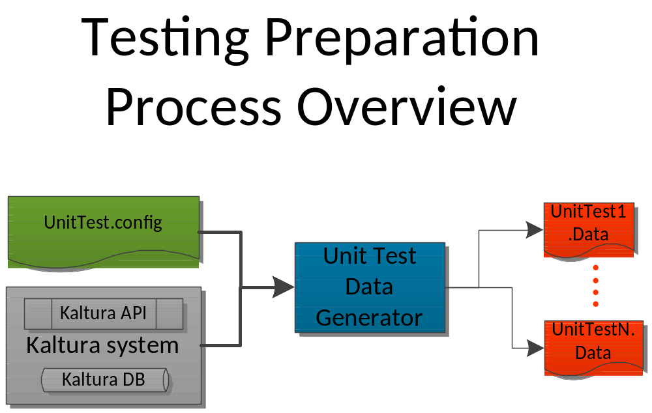Part 1: Unit test data creation – Test Preparation Process.

Part 2: Testing the wanted unit.
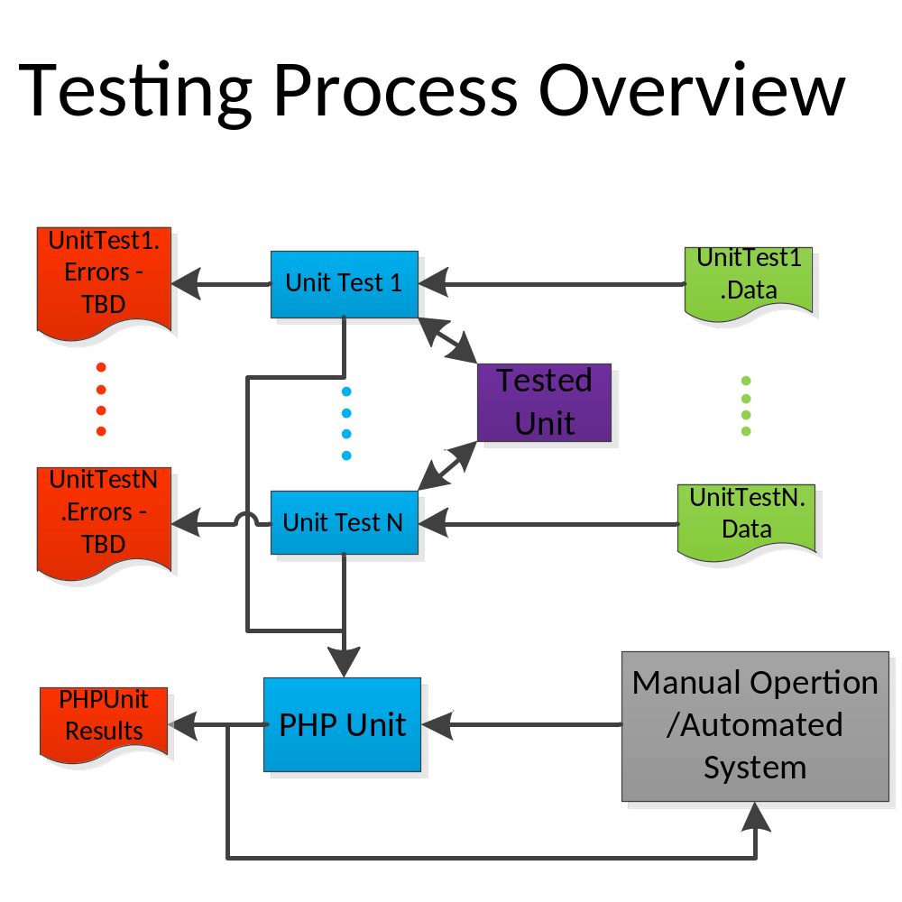

Unit Test data creation
In order to create the unit test data, so it will not depend on DB, API or other Kaltura components, you have a data generator who can take data from Kaltura API, a DB and parse it into XML.
All our unit test (and tests) is working with a data file from which they can extract the important data for the test. Each test will have its own data file.
In order to create the data file for a test you need to run UnitTestDataGenerator/generateTestData.php with the right parameter. The script gets the path to the test config file and from there it creates the data file for the tests.

Tests config file
Location: tests_data folder for every test, check Example folder for example files
The test config file is xml based file which contains the needed data identifiers for the test.
The Config file contains a general header and all the tests to be generated and includes a number of test data files to be generated, each test file includes:
1. Header – A string for the test header (will support versioning and other functionalities later)
2. File Name – The file name of the data test file: it can be relative or absolute.
3. Description – The test data description for example: “HD conversion test data”, API General test, ..,
4. Unit Tests Data – Holds all unit tests data for this file. It can hold several test cases for one test.
5. Unit Test Data – A unit test data test case. A single test data. Hold the test inputs and output references:
6. Input / OutputReference – this nodes holds the actual data identifier can be of the following types:
6.1 - Propel object / BaseObject –All the DB objects in order to be used internally for the unit tests. Requires DB connection defined in the system KConf (in order to get the objects from the DB).
6.2 – API object / KalturaObjectBase – all Kaltura API objects. Requires partnerId, admin secret the server to work against and the service to get the data from (in order to get the object via API call).
6.3 – Custom Data – all sorts of data you want to pass such as strings, integer and floating point. Will be retrieved as strings from the xml you can cast and use them as you would like.
Examples are located in the Example folder under unitTests/unitTestExample

Testing Process
The testing is done on top of PHPUnit. Each test will have its own .Data file from which he can extract data. This .Data file is generated in the previous section.
After the data has been extracted just write a valid PHPUnit test and run it.
Example .Data file are located at: unitTestExample/tests_data

Kaltura Unit Tests Infrastructure
Our unit test infrastructure is designed to work on top of PHPUnit and also supports the Zend studio 8.0 integration.
In this guide you will be explained how to set PHPUnit support under Xampp:

Set up PHPUnit (preferably under Xampp)
To set up PHPUnit under Xampp you should do the following:
1. Installing Xampp – if you don’t have Xampp installed already then install it using the KNDM – Kaltura new developer manual.
2. Updating Xampp pear – use the cmd in administrator mode and execute the following commands:
3. pear channel-update pear.php.net – Upgrades your pear in the Xampp (so you can download and install the phpunit)
4. pear channel-discover components.ez.no – get this channel
5. pear channel-discover pear.symfony-project.com
6. pear channel-discover pear.phpunit.de - Gets the phpunit channel.
7. pear install phpunit /PHPUnit – install phpunit
8. Set your Zend studio to work with PHPUnit – the Zend Studio has a plugin for PHPUnit. This plugin only works with PHP 5.3!
9. Set output xml in your Zend Studio to tests/unit_tests/results folder – the PHPUnit result folder for your convince

Kaltura Unit Test Infrastructure
Here we have 2 base classes you can use:
1. UnitTestBase – Represents a new unit test in our system which extends the PHPUnit test case.
Main functionalities and functions:
1. Can be run on PHPUnit.
2. Function provider($dataFilePath)– this function gets a path (relative or absolute) to the test data file and returns unit test data array based on the given data file ,transforms the data xml into UnitTestDataObjects.
3. Function comparePropelObjectsByFields($outputReference, $newResult, $validErrorFields)- Compares two propel objects (server side objects) by their fields ignoring the fields which are found in the $validErrorFields
For example see: KDL unit tests found at: unitTests\KDL
2. Api_v3UnitTest – Represents a new API_v3 unit test extends UnitTestBase
Main Functionalities and function:
1. Function getClient($partnerId, $secret, $configServiceUrl)- gets partnerId, admin secret and a path to config service and returns a new API-_v3 client.
For example see: KDL unit tests found at: unitTests\API_v3\MediaService

Unit Tests Data Objects:
Class UnitTestDataObject – Represents all data objects that can be obtained from the data xml.
Properties:
$type - the kaltura object type (KalturaMediaEntry, MediaInfo...)
$dataObject; - The data object to be retrieved like propel or kaltura object can be null in cases of custom type
$additionalData = array(); - Additional data for the object identifier (such as key, partnerId, secret, value) in a Key => Value manner based on the xml element attributes.

Unit Test Data Generator
class UnitTestDataGenerator – Represents the unit test data generator and can generate xml data files from a given config file
Main functionalities:
- Extracts propel objects from the DB which defined in Kconf.local by their key / id.
- Extracts API_v3 objects from the API, this requires partnerId, admin secret, service url and service name for the generator to extract this object.
- Extracts custom data as strings, you can pass any data and it will be generated with the data file.
Function:
public function createTestFiles() – creates the test files according to the given file path in the object constructor.

4. Creating a New Test
Creation of a new test is very easy, straight forward and fast! In order to do so please follow the following steps:
Test Creation:
- Select the units you wish to test also select the particular methods you wish to test.
- See what types there getting as inputs and what their output is.
- Create a new config file, from the example test file found at: unitTests\unitTestExample, listing all the data you wish to retrieve.
- Run generateTestsData.php found at: unit_test\unitTestGenerator with the path of your config file as parameter. – This will generate your data files for your tests.
- Create a new class extending the right unit test (API or Base).
- Create test methods according to PHPUnit method – more can be found at: http://www.phpunit.de/manual/current/en/
- If you wish to retrieve the data from the xml you generated you can use $this->provider($xmlDataFilePath) to get array of UnitTestDataObjects. So you can create the input for the tested method.
- If your test is an API_v3 test then you can use $this->getClient method.
- Enjoy testing!

5. Running the tests
You can use the PHPUnit to run all tests just by running the following command on cmd / shell
1. Go to unit_test folder
2. Type into the command line: phpunit unitTests
3. All tests under unitTests folder will run.

Also you can use any method of running phpunit tests here to run some or all your tests.

6. Open Issues
1. Create installation / deployment script for the unit test infrastructure including all needed data for the unit tests.
2.

